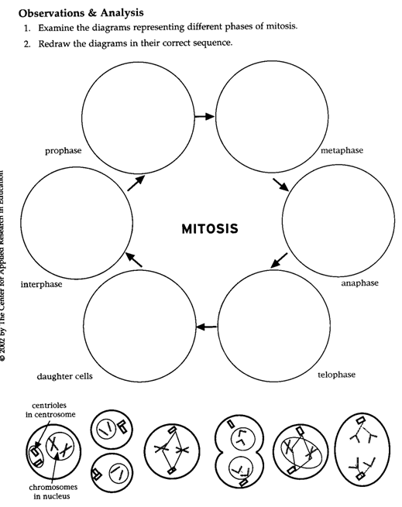
Name: _____________________________________________ Period: ____________ Date: _____________________
Objective: Identify the stages of mitosis
Procedure:
1. Read the information on Mitosis
2. Examine the handout illustrations. Then complete the “Observations and Analysis” section.
Mitosis
All multicellular organisms grow and repair injuries by reproducing the cells. The process of cell division is called mitosis. Mitosis occurs in stages: interphase, prophase, metaphase, anaphase, telophase, and cytokinesis.

Beginning at interphase, the chromosomes carrying the heredity information of the parent cell are duplicated within the confines of the nuclear membrane.

In prophase, the nuclear membrane begins to dissolve and tiny cylindrical-shaped centrioles escape the confines of a structure called a centrosome. The centrioles spread apart and throw out spindle fibers that attach to freed chromosomes.

During metaphase the centrioles move to opposite poles of the cell as chromosomes align at the midline of the cell.

During anaphase, the duplicated chromosomes split apart and are dragged to opposite poles of the cell.

During telophase, the cell begins to pinch in half. The final division and separation into two completely independent daughter cells is called cytokinesis. Each daughter cell begins a life cycle of its own.

